Installation Guide

jWebSocket
Shared Canvas Demo

1. Process application download
For the installation of this application should be downloading the packages containing the jWebSocket client and server. Shared Canvas Demo is included in this packages.
The url address where are available the application's packages for download is: http://jwebsocket.org/downloads.
Packages | Size
jWebSocketSharedCanvasPlugIn Server | 27,4 KB
jwsSharedCanvas Client | 187 KB

2. Characteristics of the installation environment
Does not require specific characteristics of the installation environment.
3. Installation process
If the operating system is Linux, the package that contains the application client must be copied var/wwwIn addition it should be given all permits through the console. The package that contains the server can be stored in any location. Before running the client in the browser, the server must be running on an IDE.
If the operating system is Windows, you must have installed Wamp that creates the folder C://wamp/www. In this folder you must copy the packet that containing the client. The package that contains the server can be stored in any location. Before running the client in the browser, the server must be running on an IDE.
To install the Wamp must take the following steps:
Step 1: Open Wamp installer and click Next.
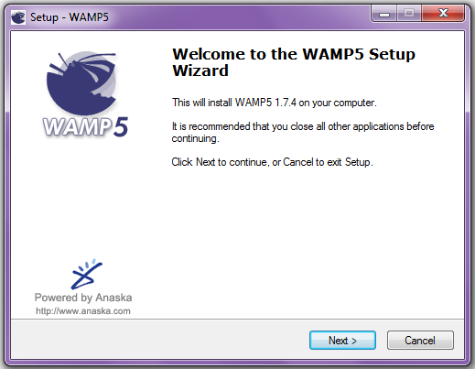
Step 2: Accept the license terms and click Next.
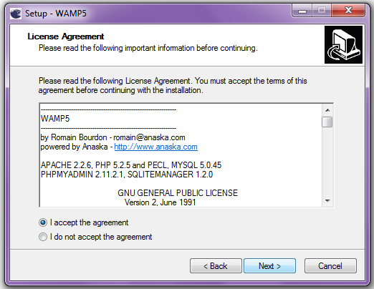
Step 3: Select the destination location where it will be installed Wamp and click Next.
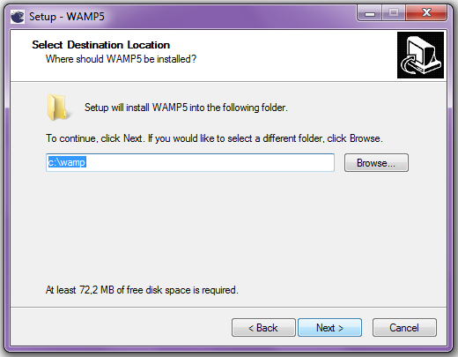
Step 4: Select the Wamp folder that will appear in the Start menu and click Next.
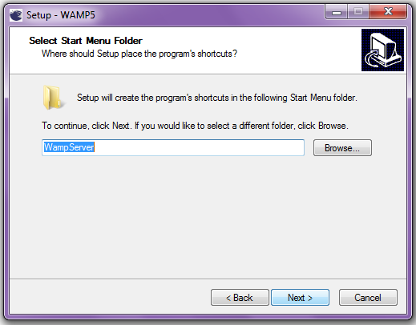
Step 5: Decide whether Wamp will be initiated to load the operating system or will be start manually when the user wants and click Next.
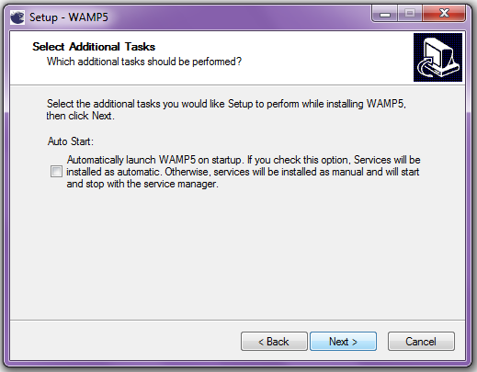
Step 6: Click on Install.
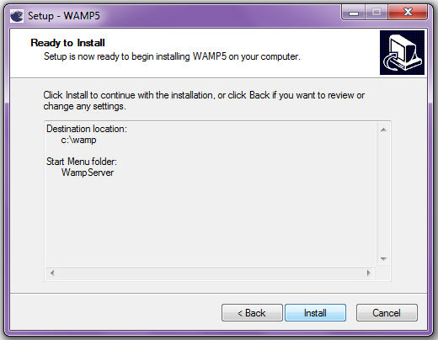
Step 7: Select the directory for the DocumentRoot and click “Aceptar”.
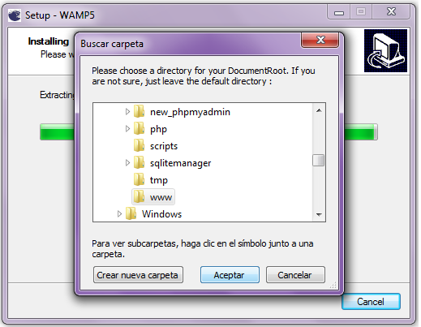
Step 8: Define the name for the SMTP server and click Next.
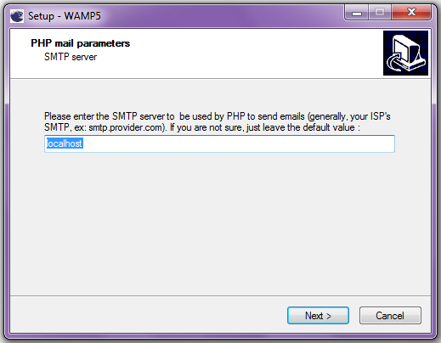
Step 9: Enter the email address to which PHP will send emails.
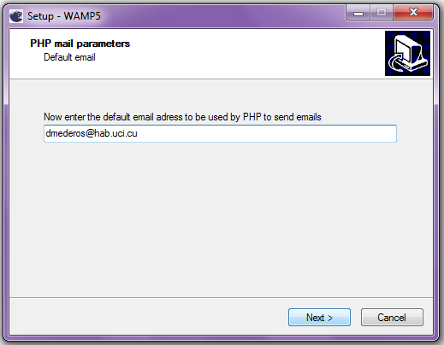
Step 10: Select the browser that will use WAMP and to click “Si”.
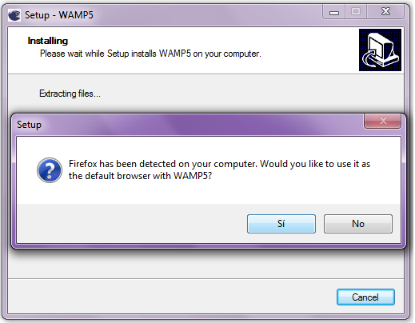
Step 11: Finish the installation by clicking Finish.
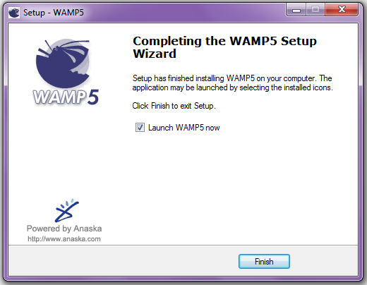
3.1 Hardware's application
The application does not use any additional hardware to operate.
4. Configuration Options
No need for any configuration for the application execution.
5. Commissioning
To run the application should start the server jWebSocket. Then you must open the Shared Canvas Demo Client using any of the browsers that support the WebSocket protocol. Then the user can start interacting with the application.
6. Application Management
To administer Shared Canvas Demo can be supported in the user manual.
In the event of any problems during installation of the application, contact:
Daimi Mederos Llanes
e-mail: daimi27@gmail.com

